**Lab 5: Identity and Access Management.**

5.1. IAM Service

Create an EC2 instance.

|  |  |
| --- | --- |
| **Goals** | * Create a user credentials and provide only read access permission to one EC2 instance to that user |
| **Time** | 1 Hours |

Sol…

Step 1: Open Services🡪 IAM.

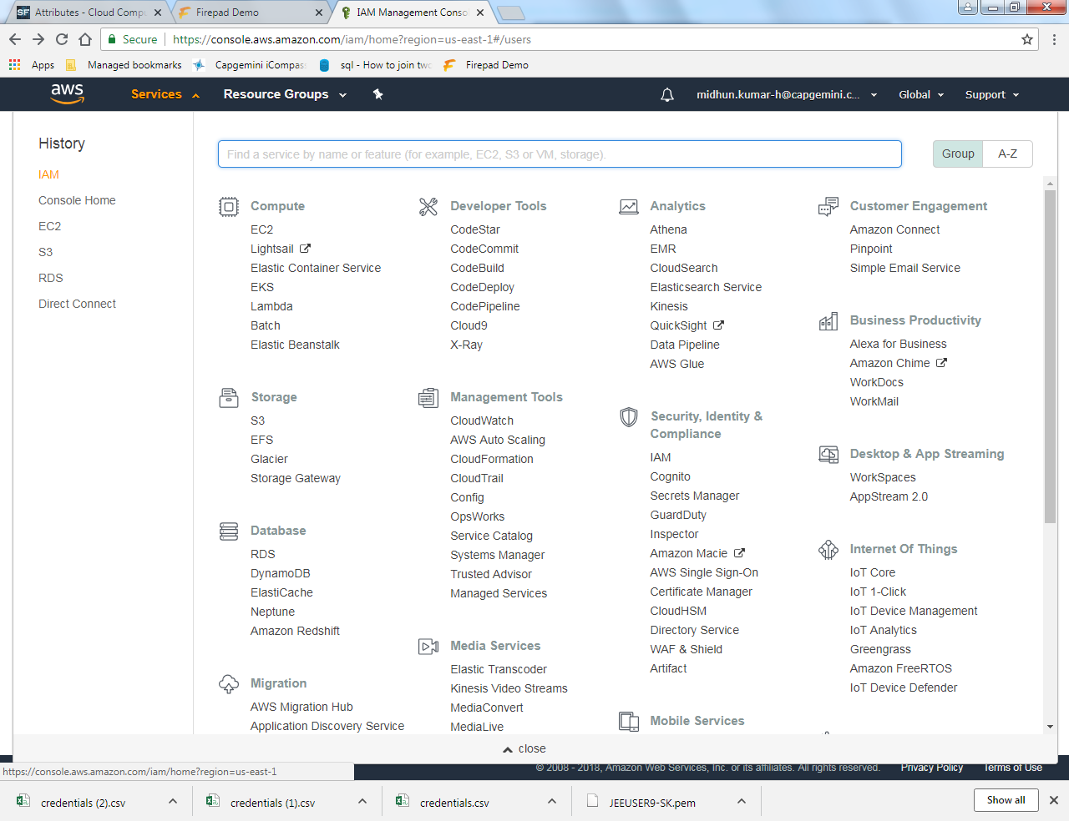

Step 2: In IAM, Open the users option present in the left panel.

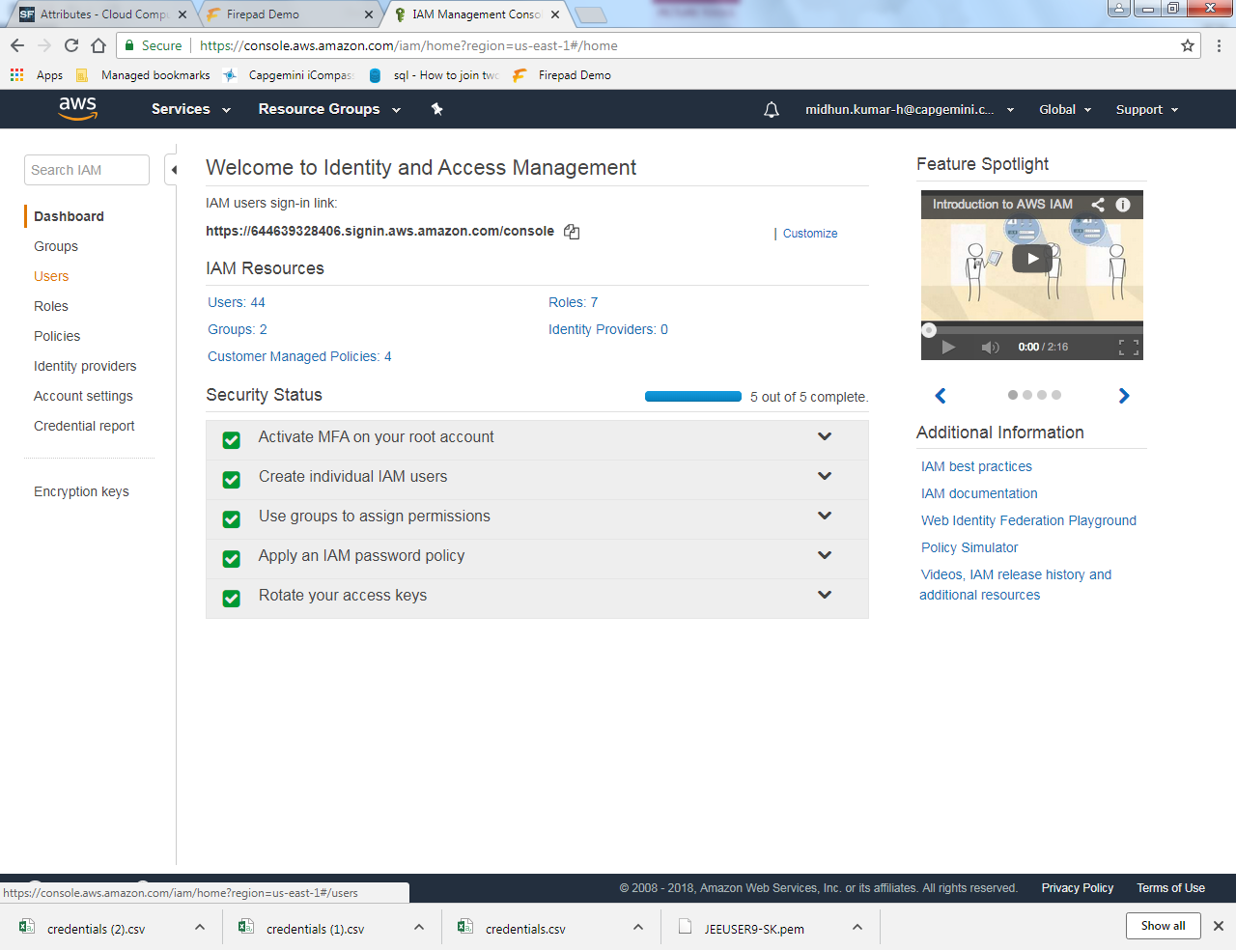

Step 3: In Users, we need to create a new user. So select the Add user option.

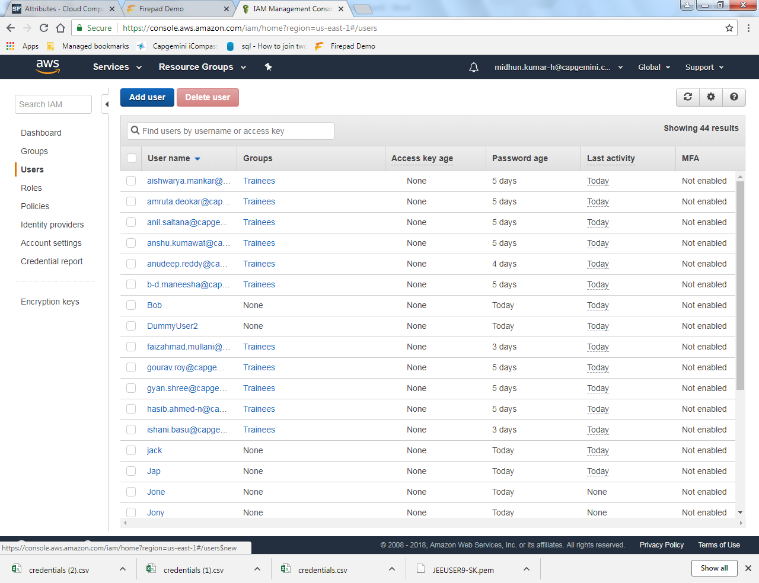

Step 4: In Add users, Type an appropriate user name and then select AWS Management Console Access🡪Custom Password 🡪 Type a password(length-12) and then Next Permissions.

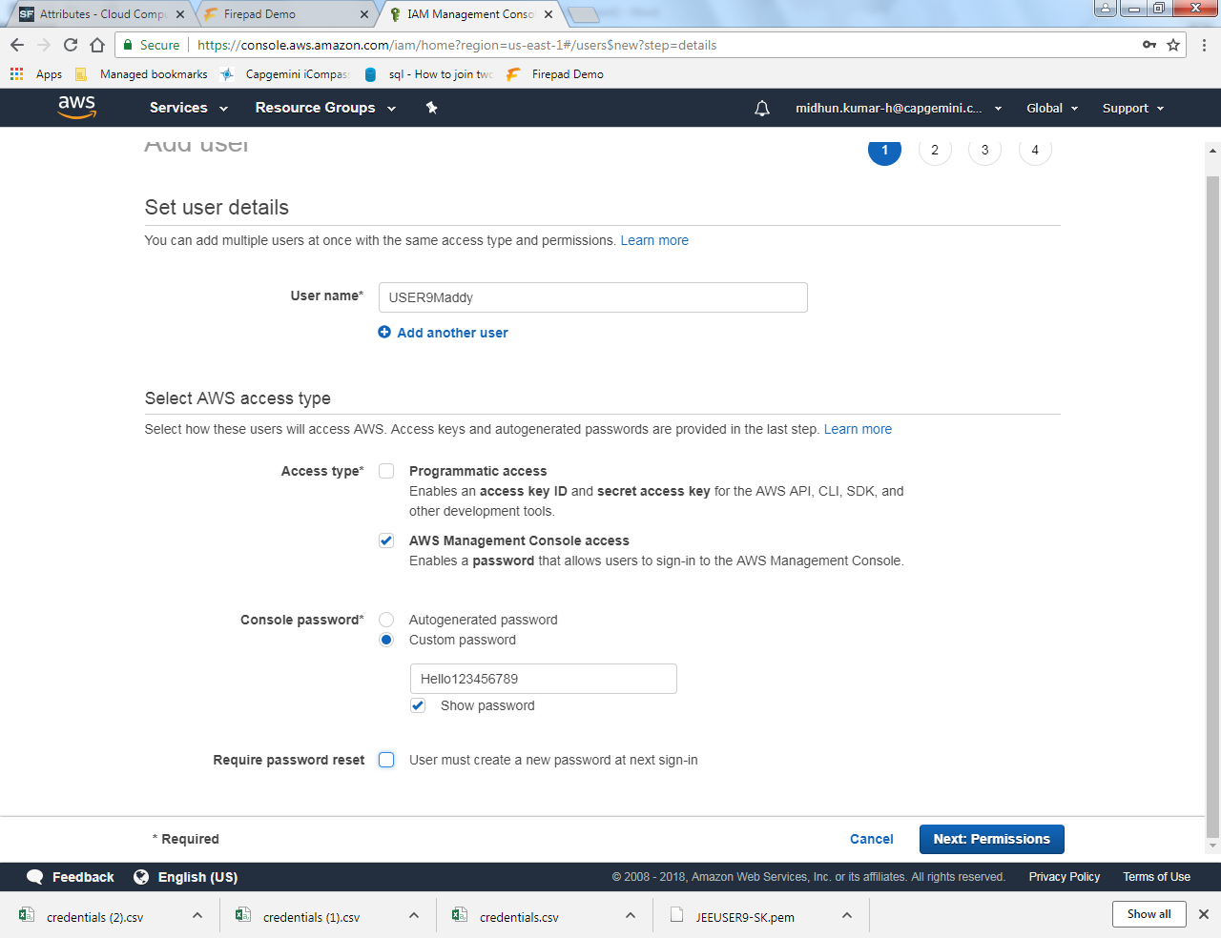

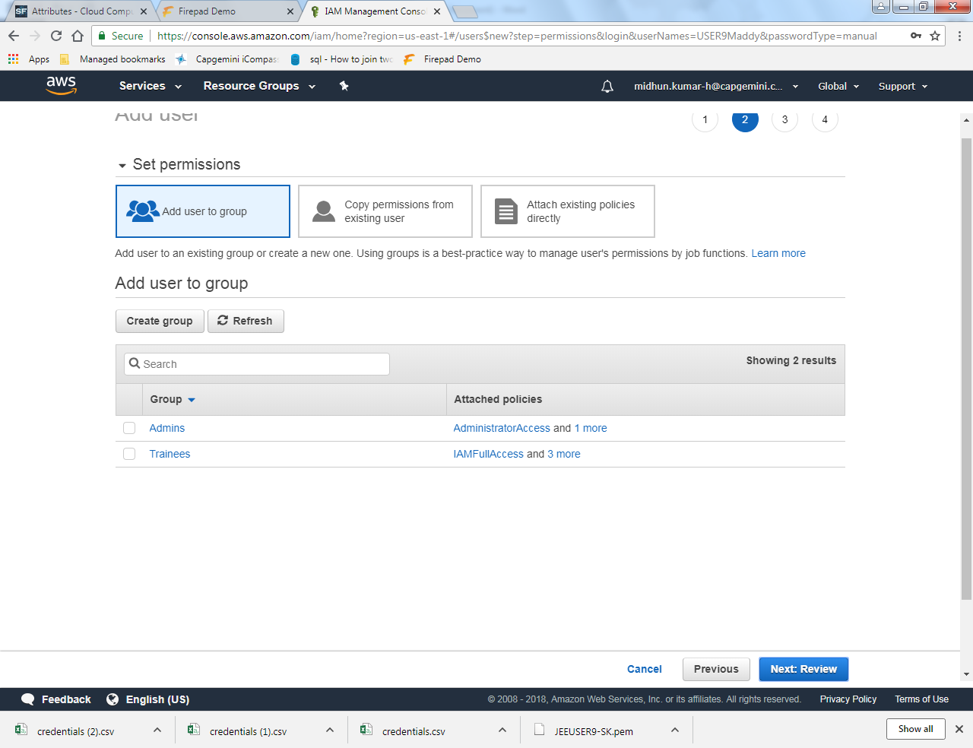

Step 5: Once you click on the Next Review, you will get a review page and now click create user.

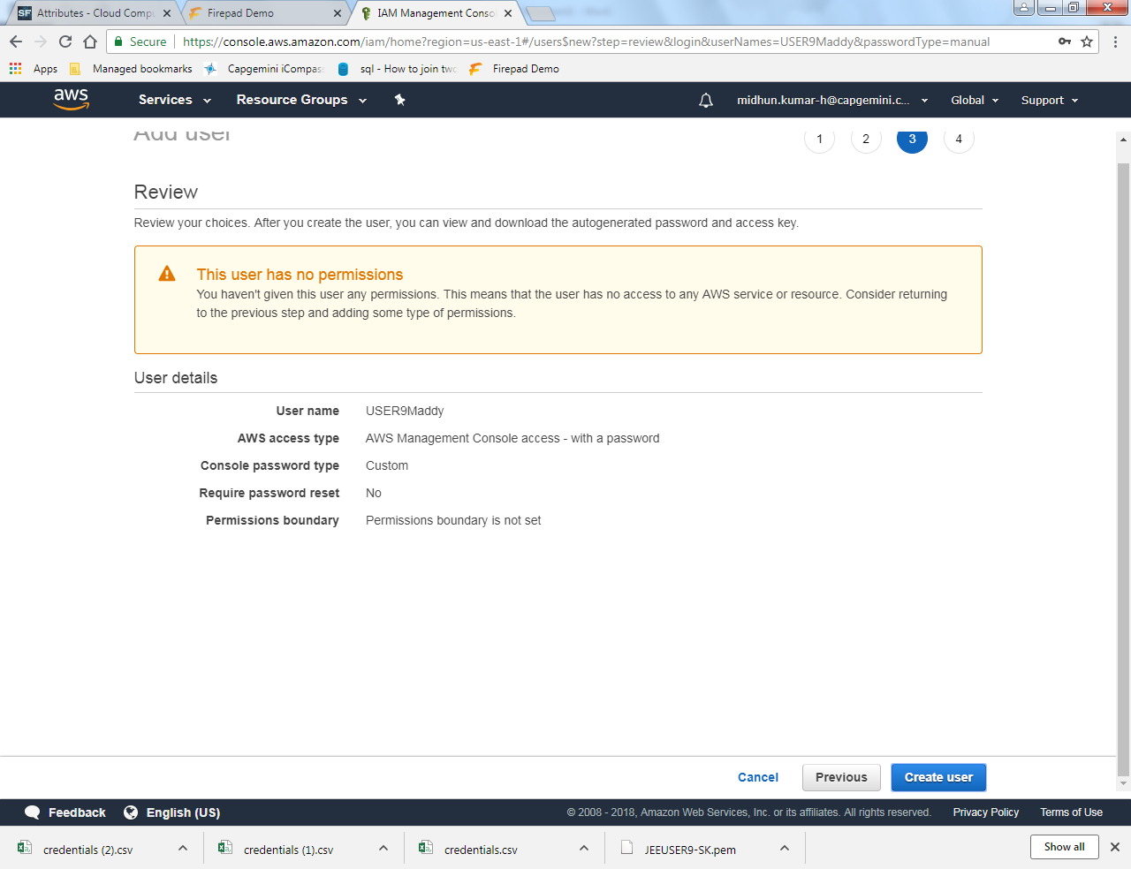

Step 6: The you get a success page. Also download the .csv file where you will be having the user credentials.

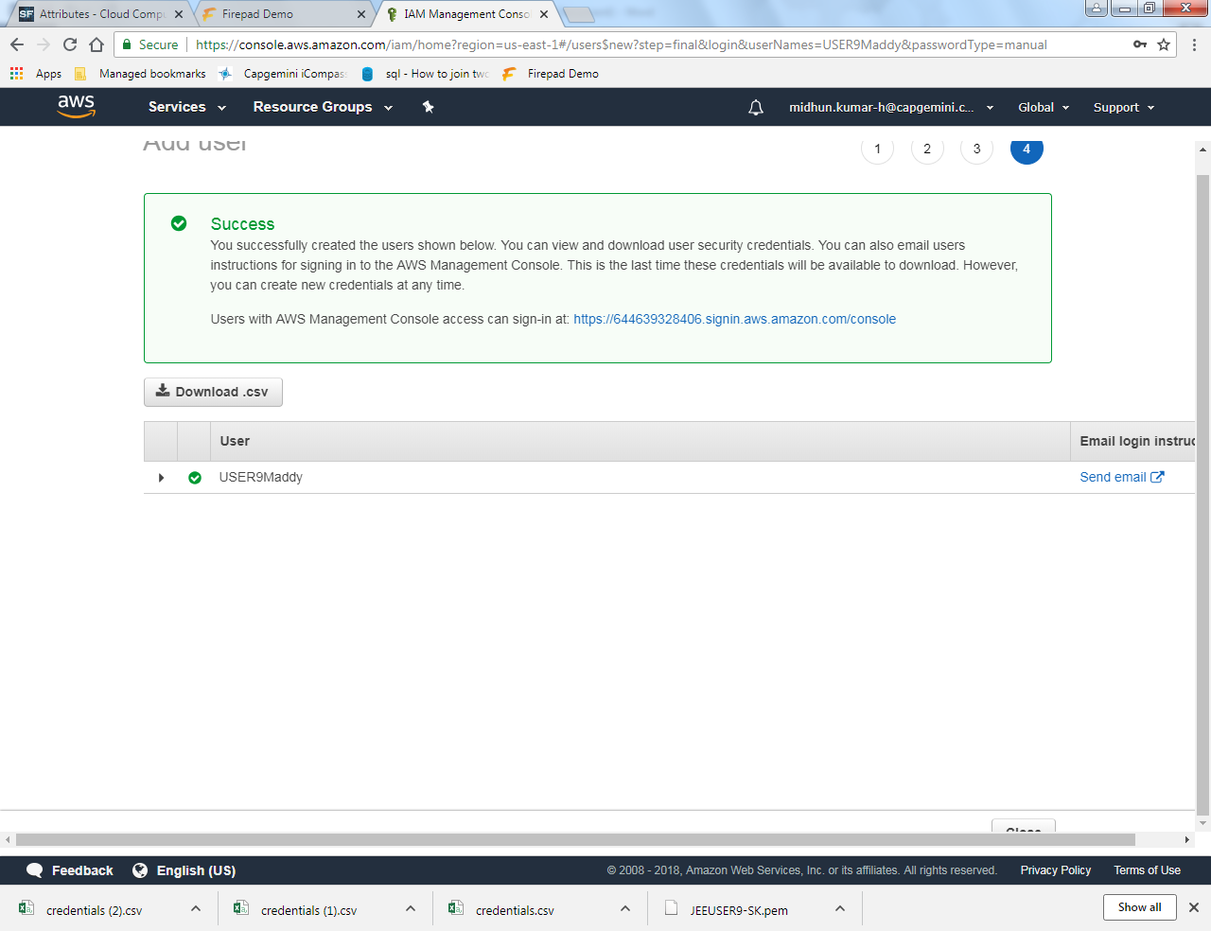

Step 7: Now select the users option from the left panel.

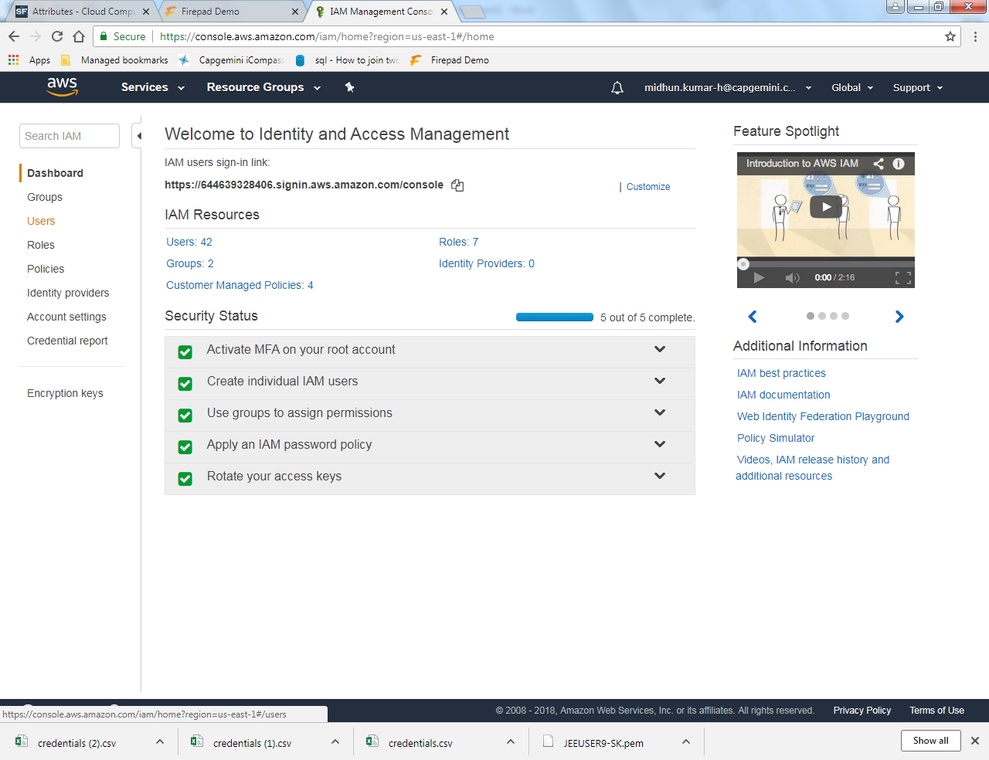

Step 8: In users, now you will be finding the newly created username in the list of users.

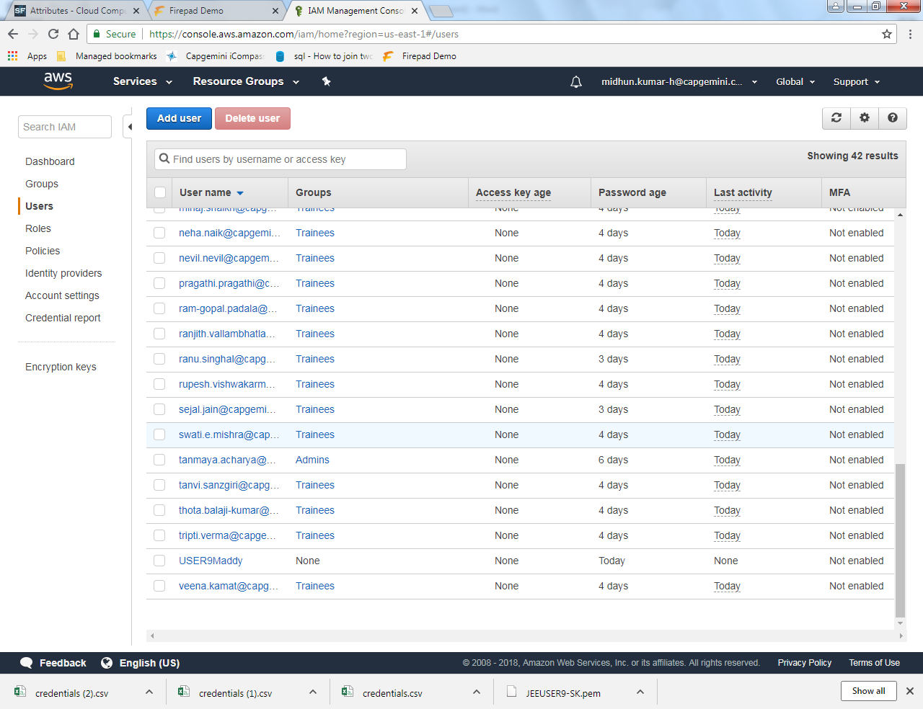

Step 9: Click on the username and check for the permissions you want to give the person using your created credentials.

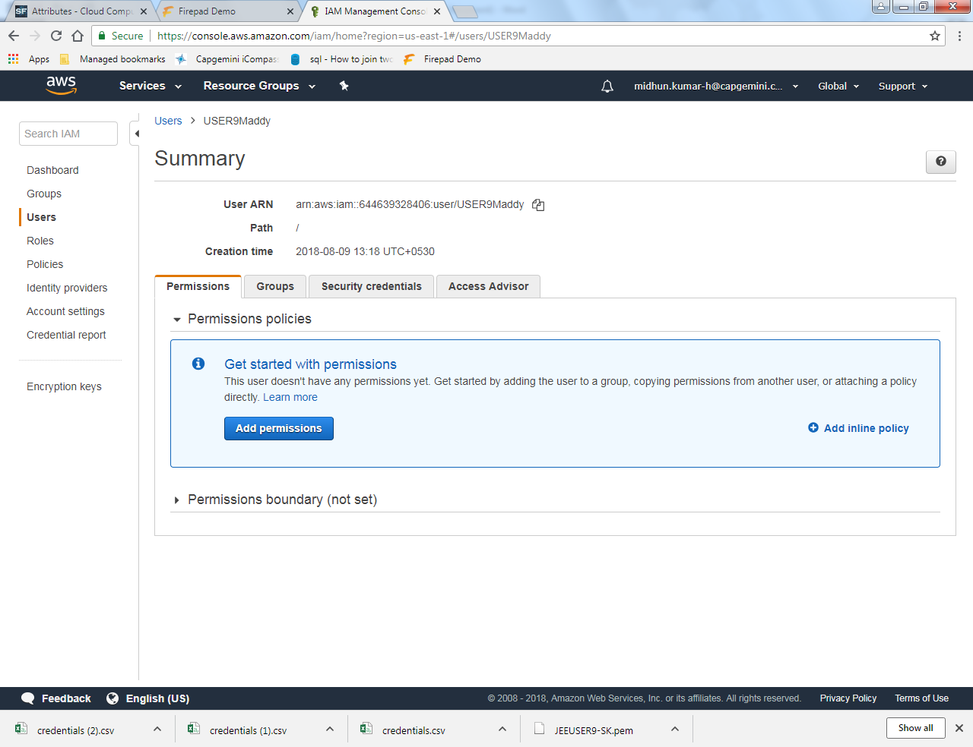

Step 10: Once you add the credentials, login using those credentials and check whether the you are able to login or not. If yes, the credentials have been created successfully.

**************************************The END*************************************